Practical 6
Using an IR Sensor with Raspberry Pi 3 and display the message using Python

IR Sensor
An IR (Infrared) sensor is an electronic device that detects infrared radiation to sense its surroundings, measure temperature, or detect motion. They are widely used in everyday items like TV remotes and in complex applications such as robotics and security systems.

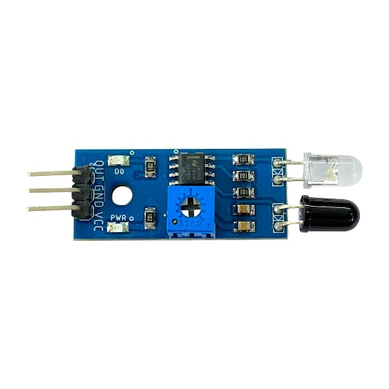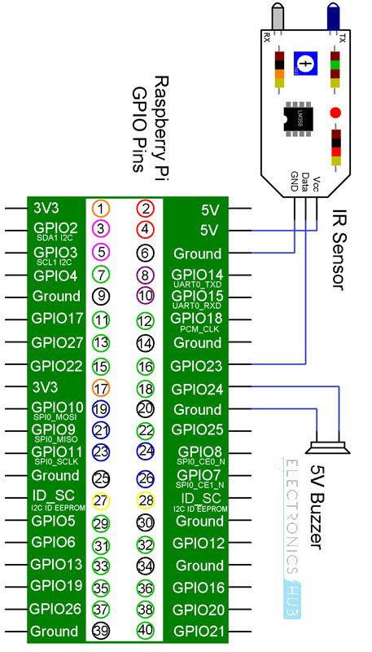

Sr. No | Condition | Output
1 | Object Detected | Low(0)
2 | No object | High(1)

Components Required
- Raspberry Pi 3 Model B
- IR Sensor
- 5V Buzzer (We are using LED instead)
- 330 Ohms transistor
- Mini Breadboard
- Connecting Wires
- Power Supply
- Computer

Data Pin of IR Sensor to GPIO23 (Physical Pin 16)
LED to GPIO24 (Physical Pin 18)

| Component | Function | GPIO Pin | Physical Pin |
|------------------|---------------------|-----------|--------------|
| IR Sensor | VCC | 5V | Pin 2 / 4 |
| IR Sensor | GND | GND | Pin 6 |
| IR Sensor | Data / OUT | GPIO 23 | Pin 16 |
| LED | Positive (Anode) | GPIO 24 | Pin 18 |
| LED | Ground (Cathode) | GND | Pin 6 / 9 |
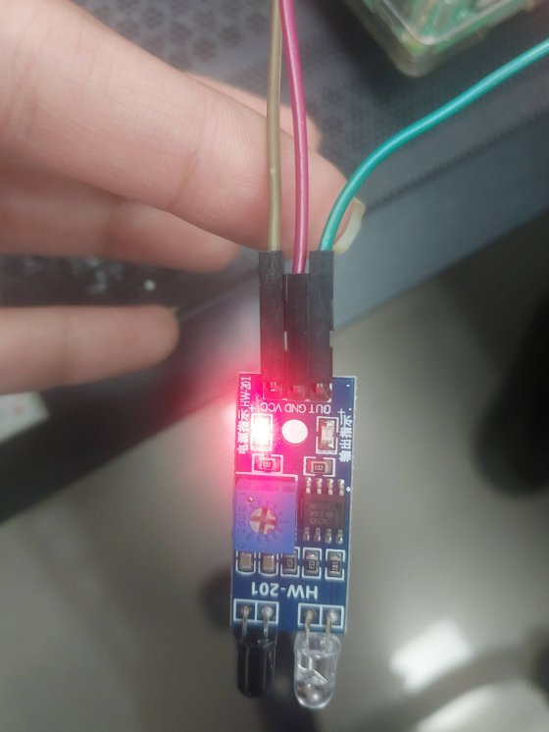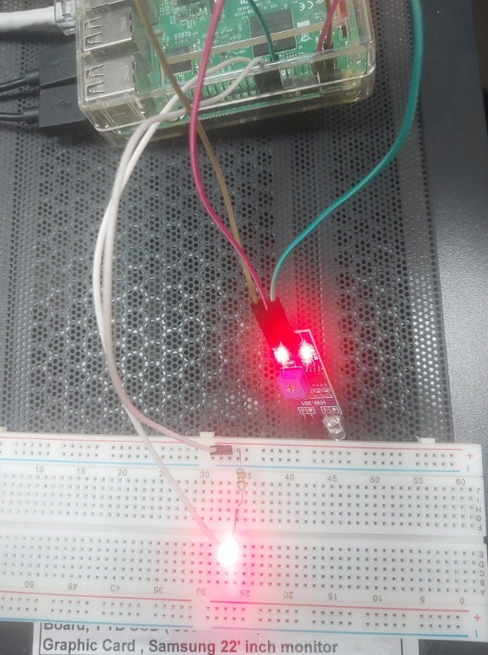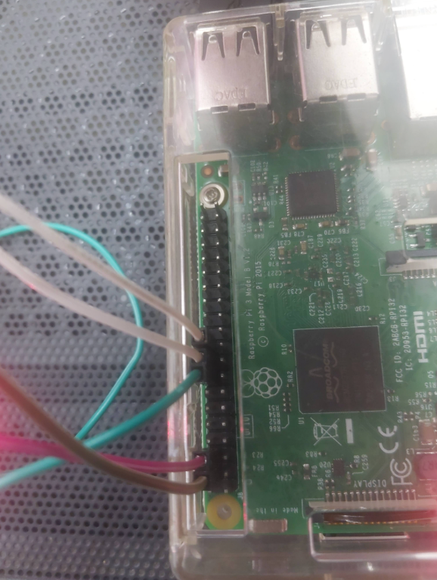

When object detected LED is solid
Code: -
import RPi.GPIO as GPIO
import time

sensor = 16
led = 18

GPIO.setmode(GPIO.BOARD)
GPIO.setup(sensor, GPIO.IN)
GPIO.setup(led, GPIO.OUT)

GPIO.output(led, False)

print ("IR Sensor Ready....")

try:
while True:
if GPIO.input(sensor) == 0:
GPIO.output(led, True)
print ("Object Detected!")
else:
GPIO.output(led, False)
print ("No Object")
except KeyboardInterrupt:
print("Program stopped by User")
finally:
GPIO.output(led, False)
GPIO.cleanup()

Output: -
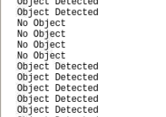

When the object is detected LED blinks
Code: -
import RPi.GPIO as GPIO
import time

sensor = 16
led = 18

GPIO.setmode(GPIO.BOARD)
GPIO.setup(sensor, GPIO.IN)
GPIO.setup(led, GPIO.OUT)

GPIO.output(led, False)

print ("IR Sensor Ready....")

try:
while True:
if GPIO.input(sensor) == 0:
print ("Object Detected")
GPIO.output(led, True)
time.sleep(0.3)
GPIO.output(led, False)
time.sleep(0.3)

else:
GPIO.output(led, False)
print ("No Object")
time.sleep(0.3)
except KeyboardInterrupt:
print("Program stopped by User")
finally:
GPIO.output(led, False)
GPIO.cleanup()

Output: -
